**SAYISAL FİLTRE TASARIMI**

**ÖDEV 1**

function butter=mylossfunc(n)

%Abdulkadir AKTABUR

%05.11.2018 rev 0

w=0:0.001:1.5;

lw2=1+(w.^(2*n));

aw=[ ];

for i=1:n

aw=(10*log10(lw2))

end

butter=aw;

end

w=0:001:1.5

x=mylossfunc(3);

y=mylossfunc(6);

z=mylossfunc(9);

figure;

plot(w,x);

hold on;

plot(w,y);

hold on;

plot(w,z);

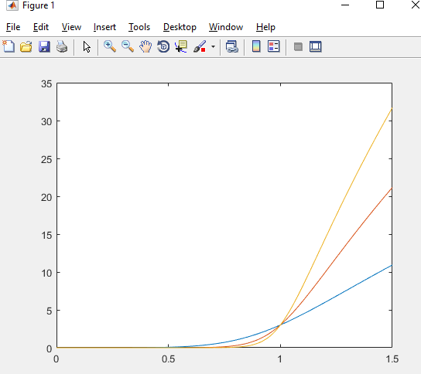

**ÖDEV 2**

function [num,den]=myButterworth(n)

%Abdulkadir AKTABUR

%04.11.2018 rev 0

num=1;

den=1;

for k=0:n-1

w=exp(j*(pi*(1+4*k)/(2*n)));

if (real(w)<=0.0001)

den=conv(den,[1 -2*real(w) 1]);

end

end

end

[num,den]=myButterworth(3)

num =

1

den =

1.0000 1.7321 2.0000 1.7321 1.0000

>> [num,den]=myButterworth(5)

num =

1

den =

1.0000 3.0777 5.2361 6.1554 5.2361 3.0777 1.0000

>> [num,den]=myButterworth(6)

num =

1

den =

1.0000 3.8637 7.4641 9.1416 7.4641 3.8637 1.0000

**ÖDEV 3**

function [num,den]=myMinOidButter(wa,wp,Aa,Ap)

%Abdulkadir AKTABUR

%04.11.2018 rev 0

n1=[-log10(10^(0.1*Ap)-1)]/(-2*log10(wp));

n2=[log10(10^(0.1*Aa)-1)]/(2*log10(wa));

n1

n2

a=[n1 n2];

eb=max(a)

ceil(max(a))

[num,den]=myButterworth(ceil(max(a)));

end

>> [num,den]=myMinOidButter(2,0.7,30,0.5)

n1 =

2.9489

n2 =

4.9822

eb =

4.9822

ans =

5

num =

1

den =

1.0000 3.0777 5.2361 6.1554 5.2361 3.0777 1.0000